**Implement HTM Persistance**

Nabeela Maham

nabeela.maham@stud.fra-uas.de

Kizito Onyema  
kizito.onyema@stud.fra-uas.de

Abstract— This report describes mainly the implementation of the serialization and deserialization of some of the class libraries in the NeoCortexApi including but not limited to *SparseObjectMatrix, InMemoryDistributedDictionary, SparseBinaryMatrix*

By this implementation, the NeocortexApi can Serialize and Deserialize its HTM Objects so that it can recall from where it stops. The Serializer records the instances of some of the HTM module to the stream and the Deserializer helps in creating the instance from the stream. The HTM keeps record of the instances of the HTM modules using the Streamwriter and then continues again from it’s last instance with the Streamreader. This is a new feature in the NeoCortexApi, as the current implemented and conducted serializations are still limited. As the NeoCortexApi is the mirror of a Human Brain, this work describes an aspect of the real life where a Human’s Brain coordinates itself and reminds the body of it last work continues his/her Work where it stopped; this emphasizes the NeoCortexApi’s cognitive ability, remembrance, continuity and efficiency.

Keywords— - serialization, deserilization, persistence

# **Intro (*Heading 1*)**

Hierarchical temporal memory (HTM) is a biologically constrained machine intelligence technology developed by Numenta. Originally described in the 2004 book. On Intelligence by Jeff Hawkins with Sandra Blakeslee, HTM is the distributed building and primarily used today for anomaly detection in streaming data. The technology is based on neuroscience and the physiology and interaction of pyramidal neurons in the neocortex of the mammalian (in particular, human) brain. The HTM algorithm is based on the well understood principles and core building blocks of the Thousand Brains Theory. In particular, it focuses on three main properties: sequence learning, continual learning and sparse distributed representations.

The Thousand Brains Theory is the core model-based, sensory-motor framework of intelligence putting together the neuroscience research developed over the almost two decades of research at Numenta and the Redwood Neuroscience Institute (founded in 2002 by Jeff Hawkins). It provides a unique interpretation of the high-level computation thought to happen throughout the neocortex and giving rise to intelligent behaviors. See Fig 1.1 and 1.2

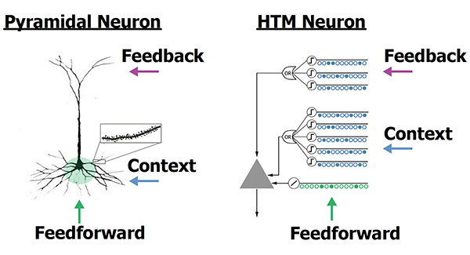

*Fig 1.1 HTM Neuron [1]*

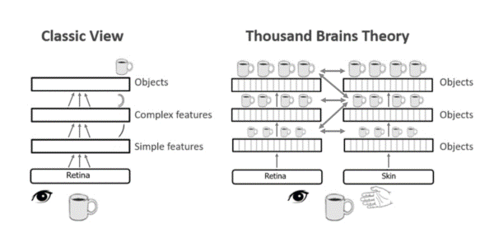

*Fig 1.2 HTM Structure [2]*

Since the HTM is based on the ideology of the neocortex in the Human Brain which has the ability of remembrance and continuity, such a function can also be created implemented as Persistence in the NeoCortexApi which could be achieved through serialization and deserialization; this means that the instances created by the HTM Modules a recorded at a point, and also willing to continue at any point in time with these points. We apply the serialization to save the data in the form of text file. We can use that data next time when you continue the experiment again in deserialization.

For the serialization, we have used the class HTMSerializer2.cs. There, we have applied different functions. It has serialized the property of integer, double, string, long, boolean and fetch the values for the deserialization. It can serialize the non-primitive data types such as cell, dictionary distal dendrite, synapse and list. Deserialize the value when we need to continue the experiment again.

# **Methodology**

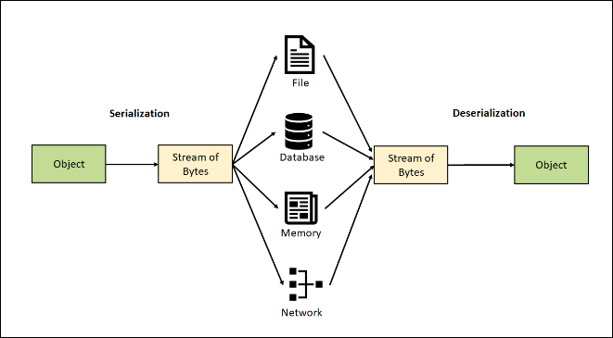

*Fig 1.3 Serialization and Deserialization [3]*

SERIALIZATION

Serialization is the process of converting an object into a stream of bytes to store the object or transmit it to memory, a database, or a file. Its main purpose is to save the state of an object in order to be able to recreate it when needed. The reverse process is called deserialization.

## How serialization works

The object is serialized to a stream that carries the data. The stream may also have information about the object's type, such as its version, culture, and assembly name. From that stream, the object can be stored in a database, a file, or memory.

### Uses for serialization

Serialization allows the developer to save the state of an object and re-create it as needed, providing storage of objects as well as data exchange. Through serialization, a developer can perform actions such as:

* Sending the object to a remote application by using a web service
* Passing an object from one domain to another

# Deserialization

Deserialization is the reverse process of serialization. It means you can read the object from byte stream. Here, we are going to use the method to deserialize the stream. See Fig 1.3

### Classes Serialized And Deserialized

*1. SparseObjectMatrix,*

Allows storage of array data in sparse form, meaning that the indexes of the data stored are maintained while empty indexes are not. This allows savings in memory and computational efficiency because iterative algorithms need only query indexes containing valid data.

*Code Sample [4]*

// Create SparseObjectMatrix

// either by dicrect creation or running experiment

int[] dimensions = { 10, 10 };

SparseObjectMatrix<int[]> matrix = new(dimensions, false);

// Serialize

using (StreamWriter sw = new StreamWriter("ser.txt"))

{

matrix.Serialize(sw);

}

// Deserizlize

SparseObjectMatrix<int[]> matrixNew = new();

using (StreamReader sr = new StreamReader("ser.txt"))

{

matrixNew = SparseObjectMatrix<int[]>.Deserialize(sr);

HtmSerializer2.IsEqual(matrix, matrixNew);

}

In the above *SparseObjectMatrix* is serialized and deserialized, using StreamWriter, the instances of the SparseObjaectMatrix class are saved and written in a text file "ser.txt". Also, using StreamReader, the instances of the SparseObjaectMatrix class are read and saved in a text file "ser.txt"

*2. InMemoryDistributedDictionary*

This creates a larger dictionary across mutliple dictionaries. And it is aids for the purpose of testing. For this dictionary its special case deals with the number of nodes = 1. In this case dictionary is redused to a single dictionary, which matches with the original none-distributed implementation of SP and TM.

In here, the StreamWriter saves the instances of the numbers and values of the InMemoryDistributedDictionary class and writes into a file "InMem.txt". The StreamReader reads the instances of the keys and key values of the InMemoryDistributedDictionary class and saves it into a file "InMem.txt"

*Code Reference [5]*

public void Serialize(StreamWriter writer)

{

HtmSerializer2 ser = new HtmSerializer2();

ser.SerializeBegin(nameof(InMemoryDistributedDictionary<TKey, TValue>), writer);

// index 0

ser.SerializeValue(this.numElements, writer);

// index 1

ser.SerializeValue(this.currentDictIndex, writer);

// index 2

ser.SerializeValue(this.currentIndex, writer);

// index 3

ser.SerializeValue(this.dictCount, writer);

// Serialize dicList

ser.SerializeBegin(nameof(dictList), writer);

// index of dictionaries

int dictCnt = 0;

// looping through dictionaries in dictList

foreach (var dict in dictList)

{

ser.SerializeValue(dictCnt, writer);

foreach (var item in dict)

{

if (typeof(TKey) == typeof(int))

{

// Create Element with syntax Key__Value

var writeValue = item.Key.ToString()+"__"+item.Value.ToString();

ser.SerializeValue(writeValue, writer);

}

else

throw new NotSupportedException();

}

dictCnt++;

}

if (this.htmConfig != null)

{ this.htmConfig.Serialize(writer); }

ser.SerializeEnd(nameof(InMemoryDistributedDictionary<TKey, TValue>), writer);

}

public static InMemoryDistributedDictionary<int, int> Deserialize(StreamReader sr)

{

InMemoryDistributedDictionary<int, int> newDict = new InMemoryDistributedDictionary<int, int>();

*2. SparseBinaryMatrix*

Implements the sparse matrix which contains binary integer values only.

Here, the *SparseBinaryMatrix* is serialized and deserialized, using StreamWriter, the instances of the SparseObjaectMatrix class are saved and written in a text file "ser.txt". Also, using StreamReader, the instances of the *SparseBinaryMatrix* class are read and saved in a text file "ser.txt". This behavior can be seen in *Code Sample [6]*

*Code Reference [6]*

// Create SParse BinarySparseMatrix

// either by dicrect creation or running experiment

int[] dimensions = { 100 , 100 };

//IDistributedDictionary<int, int[]> dict = new();

SparseBinaryMatrix binaryMatrix = new(dimensions, false);

// Serialize

using (StreamWriter sw = new StreamWriter("Binary.txt"))

{

binaryMatrix.Serialize(sw);

}

// Deserizlize

SparseBinaryMatrix newBinary = new();

using (StreamReader sr = new StreamReader("Binary.txt"))

{

newBinary = SparseBinaryMatrix.Deserialize(sr);

HtmSerializer2.IsEqual(binaryMatrix, newBinary);

}

*HTM Models Called During Serialization*

*1. ModuleTopology*

*At the initiation of the serialization process, the serialized class calls some of the existing HTM modules and Serializers which are in Heirachy. The ModuleTopology is part of the HTMmoduleTopology which gets called by SparseObjectMatrix and SparseBinaryMatrix during the Serialization Process.*

*These modules have Hierarchical functions in the HTM structure which also contributes to the creating of the instances of the HTM.*

*Gg*

Hierarchical temporal memory (HTM) is a biologically constrained machine intelligence technology developed by Numenta. Originally described in the 2004 book. On Intelligence by Jeff Hawkins with Sandra Blakeslee, HTM is the distributed building and primarily used today for anomaly detection in streaming data. The technology is based on neuroscience and the physiology and interaction of pyramidal neurons in the neocortex of the mammalian (in particular, human) brain.

The HTM algorithm is based on the well understood principles and core building blocks of the Thousand Brains Theory. In particular, it focuses on three main properties: sequence learning, continual learning and sparse distributed representations.

The Thousand Brains Theory is the core model-based, sensory-motor framework of intelligence putting together the neuroscience research developed over the almost two decades of research at Numenta and the Redwood Neuroscience Institute (founded in 2002 by Jeff Hawkins).

It provides a unique interpretation of the high-level computation thought to happen throughout the neocortex and giving rise to intelligent behaviors.

Htm persistance seri

*HTM Models Called During Serialization*

*1. ModuleTopology*

At the initiation of the serialization process, the serialized classes ca